**Recursion**

The meaning of « Recursion » as a word, away from programming :

repeating oneself 🡺 تكرار الشيء لنفسه

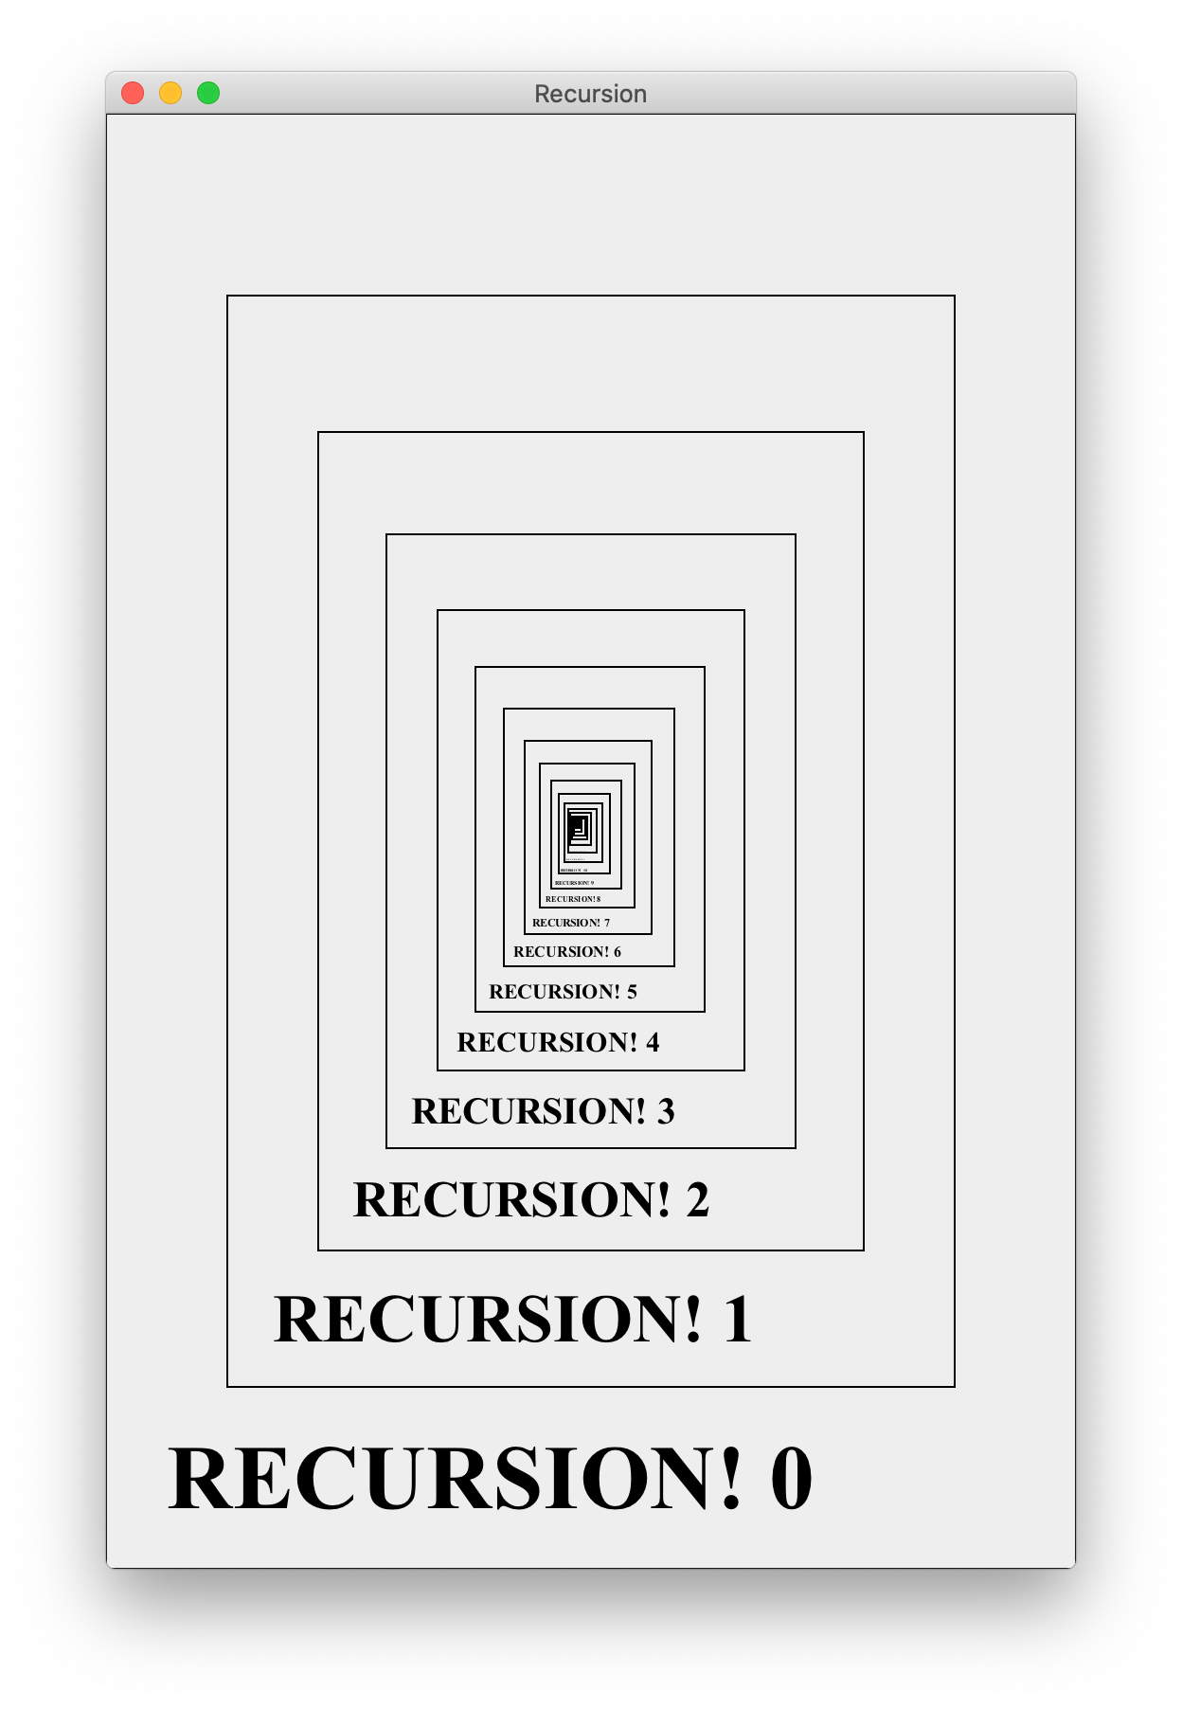

**FunctionX()**

**{**

**…………**

**…………**

**FunctionX()**

**…………..**

**}**

When you see a function , sure it contains a code and Among this code we find a call to the function it self , so here directely we say : it’s a recursive function

Because the fuction call it self , and this function make an infinite loop ,so we will get run time error , so here we need something (code) to stop this infinity .

And sure here we will use If Statement,

So Recursive function contain two part :

1 - Calling the function itself +

2- code wich will stop the infinity loop (calling)

**The first part named : Recursive Base**

**The second part named : Base Case**

**Note :**



**Void rec(int n){**

**If (n == 0 ) {**

**Return ;**

**}**

**This function don’t return any value because in the beginning we write voide , so for quite this function we must write retrun , but return nothing (no 0 because 0 is int )**

**Merge Sort**

**As The name refere this is sort algorithm, so it sort our index array , but the special thing in this algorithm that it cout on Principle of division and grouping in sorting process , so this algorithm divise our array and make the problem smaller as the picture refere , we continue the division even we arrive at a poit that we can’t divise**

**Anything , so here we will have each index from the array lonely,**

**So now we start grouping buy mege evry part of the array but in the good order as the picture refer .**

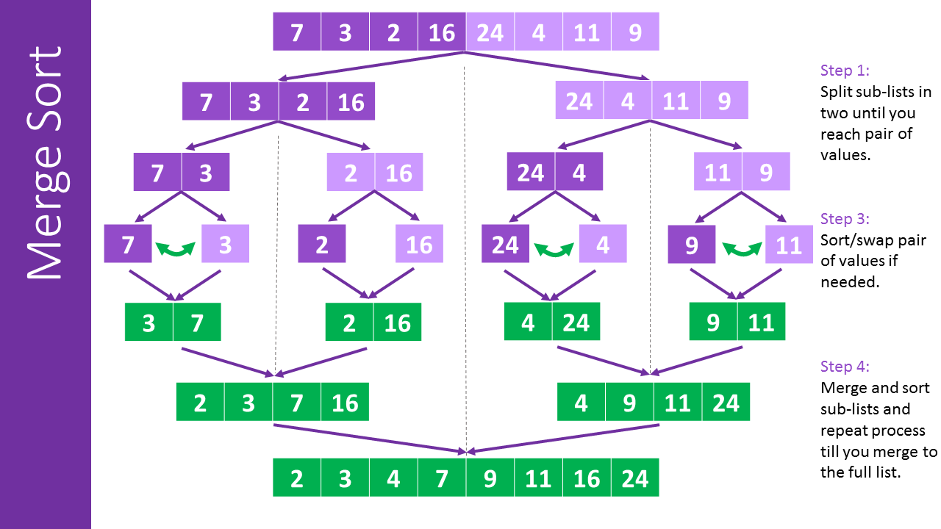

**O (n log n )**

**Ω (n log n) : also in the good-case scinario the algorithm cross all the steps because it not smart like bublle sort**

**And sure there is no best algorithm , but we choose the best one base on our projects , if there is the best one so we will learn it only**